PN 17 is situated to the south of Harrogate, west of the A61 and immediately north of Spring Lane in the village of Burn Bridge. It forms part of a pastoral landscape that separates the northern edge of Burn Bridge and Pannal with the southern urban edge of Harrogate. The pastoral landscape includes dispersed settlements of farms/cottages within surrounding farmland.
The allocation site consists of a broad ribbon of land approximately 100m wide, with an area of c.3.2ha, extending from Spring Lane Farm in the west to Clark Beck in the east. It comprises pastoral land, sub-divided into two fields bounded by hedgerows and occasional hedgerow trees. Spring Lane and the residential development of Burn Bridge bound the site to the south, the Clark Beck bounds the site to the east. There is no development within the site.
Landscape character is defined as a distinct and recognisable pattern of elements that occur consistently in a particular type of landscape. Patterns in the landscape including vegetation cover, land use, connectivity, heritage and cultural associations, activity or tranquillity, and which combine together to create landscape character.
During the site visit, the landscape of the site and wider study area were appraised in relation to the established Local (District) Landscape Character Areas.

The proposed allocation of PN 17 is neither legally compliant nor sound for the following reasons.

DISTRICT CHARACTER AREA (DCA)
The site and wider study area lies wholly within District Landscape Character Area 60: Upper Crimple Valley as defined by Harrogate Borough Council [7b].
Key Characteristics of Character Area 60, of relevance to the application site, are as follows:
A small scale valley landform with gently rolling valley sides incised by small tributaries of the River Crimple;
The area includes small blocks of woodland and trees fringing water courses;
An irregular pattern of fields exist, much of which is grassland; and
A complex network of public footpaths and bridleways offer easy access to the landscape.
The Character Area Assessment records the following:
“Sensitivities & Pressures
This area is important to both the rural setting of Harrogate and is important in preventing the coalescence of Pannal with Harrogate.
This rural, pastoral landscape is sensitive to the changes due to new development extending the urban edge.
The area contains a large amount of scattered settlement, and as such the landscape has limited capacity to accept additional development without adverse change to its character.
Guidelines
Aim: To protect the character of the area and its role in separating Harrogate from Pannal and provision of a rural setting to the urban edge.
Distance between the extents of the two settlements must be maintained and development proposals must fully assess the predicted impact on landscape character of the valley and its role in providing a rural setting to Harrogate and Pannal and maintaining the separation between the two.
The impact on views in the area must also be considered.”
The site proposals in relation to District Character Areas 60: Upper Crimple Valley
The site conforms to the identified qualities of the District Character Area: 60 and forms part of a rural landscape, the extent of which is defined to the southern edge by Spring Lane.
To the south of Spring Lane, adjacent to the site, the built edge of Burn Bridge marks a well-defined boundary between the settlement and the surrounding pastoral landscape. This distinction is clearly discernible for travellers along Spring Lane and in views from the public rights of way within the countryside to the north.
Effects on landscape character
The magnitude of change brought about by the proposal is measured against the District Character Area 60: Upper Crimple Valley and against site assessment.
A particular and valuable landscape quality of the proposed allocation site is the contribution it makes to a well-defined boundary to the adjacent built edge of Burn Bridge. The built edge faces Spring Lane, and associated domestic paraphernalia is screened within rear gardens away from the road.
Spring Lane separates the allocation site (PN17) from the edge of the settlement and this boundary is reinforced by the roadside hedgerow. The clear definition of the rural landscape character of the site from the existing settlement is appreciated from both Spring Lane, in its approach to the village, to those parts of the village within the Conservation Area, and also in views from the public rights of way within the wider landscape and those on the edge of the village.
The allocation and development of this landscape would not only reduce the extent of the key features of the Character Area 60, but would diminish the landscape setting of the village and the perception of a distinct and rural landscape on the edge of the village. This change of perception would be appreciated from the settlement, from roads on the edge of the settlement and within the wider SLA, and also from dwellings in the wider area and for users of the extensive network of recreational footpaths in the local area.
The sensitivity of the above landscape character areas, and the magnitude of change they will experience as a result of the proposed development are summarised below:
Significance of Effects on Landscape Character
Receptor | Sensitivity of  Receptor | Magnitude  of change | Significance of Effects on Landscape Character
District Character Area 60: Upper Crimple Valley (including Special Landscape Area | HIGH | HIGH | MAJOR ADVERSE
The potential effects of this proposed allocation on landscape character have also been assessed by landscape architects from HBC and recorded within the Built and Natural Environment Site Assessments: New Sites 2017.
The authors found the landscape character of the proposed allocation site consistent with the wider SLA of which it is a part and the conclusion of their assessment is reproduced in full below.
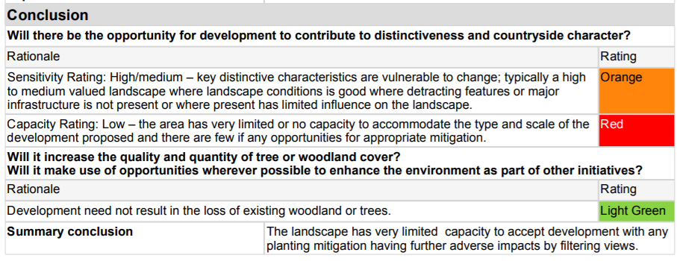
This conclusion accords with our own assessment in that there would not be landscape capacity to accommodate the proposed allocation and that impacts would not be capable of mitigation.
RELATIONSHIP OF PROPOSED ALLOCATION PN17 WITH EMERGING POLICY AND NPPF.
The Special Landscape Area
Proposed Policy NE4 : Landscape Character, identifies this area as part of the Crimple Valley Special Landscape Area (SLA). The proposed allocation PN17 would be within the SLA as the emerging local plan does not contain any proposal to remove this area from the SLA, neither does the emerging policy GS3: Development Limits include any proposal to include the proposed allocation within the development limits of the adjacent built-up area.
Policy NE4 records:
The Special Landscape Areas are valued locally for their high quality landscape and their importance to the settings of Harrogate, Knaresborough and Ripon. The designation reinforces the importance of these landscapes and their high sensitivity to inappropriate development which would adversely impact on the quality of the area designated. Development proposals within these areas are required to meet the following criteria:
F. Avoid significant loss of key characteristics that contribute to the Special Landscape Area and the setting of Harrogate, Knaresborough and Ripon.
G. Ensure that development proposals are linked to existing settlements and are designed to integrate the urban edge with the countryside and where appropriate to enhance the appearance of the urban fringe.
The allocation of PN17 would conflict with both F. and G. in that the allocation would result in the direct loss of part of the SLA and impact adversely upon the landscape character of those areas of the SLA beyond the allocation and upon the perception of the SLA from the adjacent settlements. The existing edge of the SLA to Burn Bridge along Spring Lane is strongly and clearly defined and there is no potential therefore for enhancement.
The Special Landscape Area (SLA) designation currently applicable (Draft Policy NE4: Landscape character) identifies the significance of this area as “…..valued locally for their high quality landscapes and their importance to the settings of Harrogate, Knaresborough and Ripon…. ”. The Local Planning Authority (LPA) reviewed the SLA designation in 2011, updated in 2016 and confirmed the designation in this area. No revised assessment of the SLA, or of those parts that would remain were these designations to be confirmed, has been presented to allow any scrutiny of the process by which the SLA could be redefined.
The SLA is also to be considered a valued landscape in terms of the National Planning Policy Framework (NPPF 109). In a recent appeal decision of 6th September 2017 (Appeal ref APP/E2734/W/16/3160792, Cornwall Road, Harrogate) the inspector noted in his decision (Para.36) “….the simple fact of SLA designation is evidence of value having been placed on its qualities in a formal, documented and spatially defined sense.” Paragraph 109 of the NPPF states that “the planning system should contribute to and enhance the natural and local environment by: protecting and enhancing valued landscapes, geological conservation interests and soils;….”. An allocation of PN17 would not only have a direct effect on the area allocated, but would importantly change the contribution of these areas to the wider designated landscape, and would diminish the quality of the landscape character of those remaining parts of the Special landscape Area and be in conflict with the NPPF.
Development Limits and Heritage Assets
Proposed policy GS3: Development Limits, identifies criteria where development outside development limits could be supported, and include the following.
C. It would not result in coalescence with a neighbouring settlement.
D. It would not have a significant adverse impact on the character and appearance of the surrounding countryside or heritage assets.
The exceptions to the presumption against development beyond proposed development limits as expressed in this policy would apply to PN17.
Coalescence can be a direct physical effect of built form joining across a previous undeveloped area and removing any gap that had previously distinguished the pattern of built form into discernible areas, or settlements. It is also the case that coalescence is perceived to occur when the effect of development is to diminish the apparent effectiveness of landscape gaps between settlements for people using or viewing the landscape areas. In such cases the loss of opportunity to appreciate the extent of open country between settlements will result in the diminution of perception of such a gap and an impression that development is in closer proximity to other developed areas such that they can be thought to coalesce.
The SLA forms an open area of countryside between Burn Bridge and the outskirts of Harrogate and can be experienced as such for the total length of the proposed PN17 allocation from its boundary with Spring Lane. The allocation would prevent any effective appreciation of the relationship of the SLA with the edge of Burn Bridge from the public road and would reduce the perception of the gap between this settlement and Harrogate to the North.
The allocation proposed would reduce the effectiveness of the SLA in preventing the perception of coalescence of built form.
Part D of proposed Policy GS3 reflects the objectives of Policy NE4 with respect to landscape character and visual amenity and also references heritage assets. In so far as the policy would not support the allocation with respect to harm to landscape character and visual amenity the assessment made with respect to conflict with Policy NE4, would also apply in this case.
This policy, which seeks to protect the character and appearance of a Conservation Area, includes in the justification (at 6.24) reference to the importance of the setting of a conservation area. The need to consider the contribution of the setting of heritage assets is referenced by paragraph 128 of the National Planning Policy Framework.
The proposed allocation site does not directly abut the Pannal Conservation Area, however it is viewed from that part of the Conservation Area that includes Woodcock Hill, from where a ‘key view’ is identified in the Conservation Area Character Appraisal. The appraisal also identifies Strategic Pedestrian Routes, both at Woodcock Hill and also close to the crossing of Clark Beck by Spring Lane. The impact of development of an allocation from views in these locations Smeeden Foreman have assessed as ‘major adverse’.
The adverse impacts upon views from the Conservation Area, and adverse impacts on the landscape character, will impact on the perception of the setting of the Conservation Area for residents and all those entering or leaving the Conservation Area on Spring Lane, or approaching on any of the Public Rights of Way in the Clark Beck Valley.
This assessment is supported by the conservation officer’s assessment from HBC and recorded within the Built and Natural Environment Site Assessments: New Sites 2017; the conclusion of their assessment is reproduced in full below.
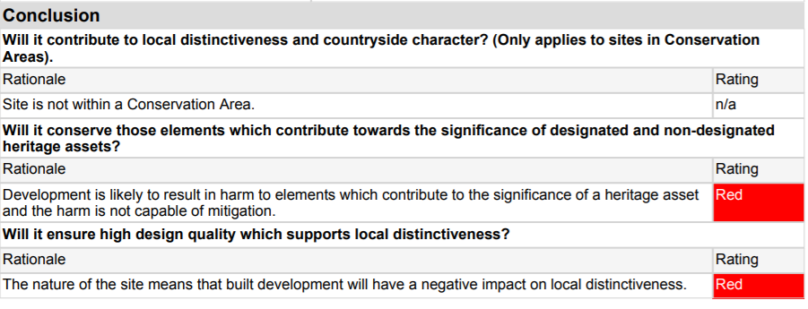
Draft policy HP2 Heritage Assets of the emerging local plan and Paragraph 17 and 129 of the NPPF recognises the importance of the setting of heritage assets and planning authorities are required by Para. 129 of the NPPF to consider the setting of a heritage asset in considering the significance of any asset that may be affected by a proposal. Para. 17 of the NPPF deals with Core Planning Principles and includes “conserve heritage assets in a manner appropriate to their significance, so they can be enjoyed for their contribution to the quality of life for this and future generations.” The allocation of PN17 has been identified as having the potential to adversely affect the landscape setting of the Pannal Conservation Area and would be in conflict with both emerging HBC policies and with the NPPF.

THIS IS THE CONTINUATION DOC to BOX 6 Attached in FULL

