Objection to Proposed developments PN17, PN18 and PN19 – Environmental Assessment

I wish to OBJECT to the proposed developments PN17, PN18 and PN19 as outlined in Harrogate Borough Councils (HBC) Draft Local Plan. The Environmental Impact Assessment clearly illustrates the significant negative effects of these developments.

Special Landscape Area (SLA)

All of these sites are within the Crimple Valley – an area classified by HBC as a SLA given its unique character. In 2011 HBC issued document “Review of Local Landscape Designations: Special Landscape Areas” which reviewed whether Green Wedges and SLA should be maintained in context to the district local plan. Five tracts of land within the Crimple Valley SLA were identified for removal from this designation. None of the development sites PN17-19 were included within the scope of this review for removal. Whilst an assessment should be undertaken for all developments within the Crimple Valley SLA this review would suggest that there are more appropriate sites than PN17-19.

Flood Risk

PN19
PN19 is located within the active floodplain of the River Crimple – this watercourse has been classified as a Main River by the Environment Agency. A significant portion of PN19 is within Flood Zone 3b as outlined by the Flood Map below.

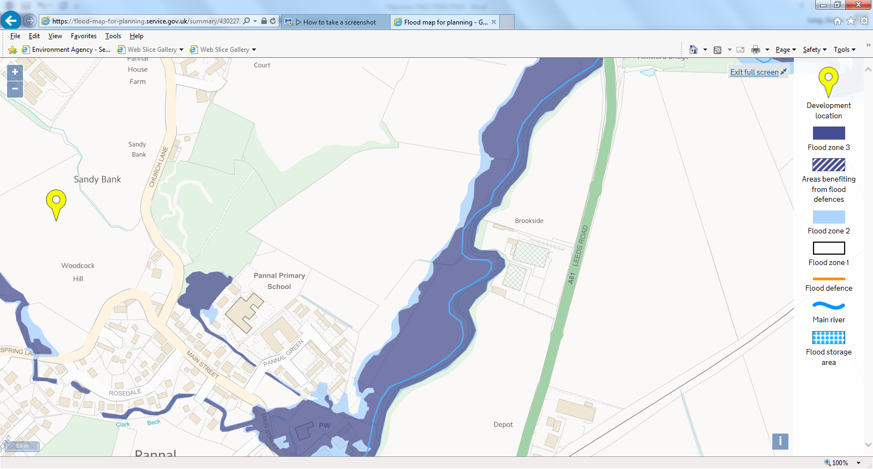

Defra guidance “Flood Risk Assessment in Flood Zones 2 and 3” states Only water compatible developments or essential infrastructure developments that have met the requirements of the exception test are allowed in the functional floodplain.
Show that any water compatible or essential infrastructure developments have been designed to:
- stay safe and operational during a flood
- avoid blocking water flows or increasing flood risk elsewhere
- avoid loss of floodplain storage (ie loss of land where flood waters used to collect)
Under this guidance residential properties are classed as “More vulnerable”. The Table below taken from Defra guidance presents Flood risk vulnerability and Flood zone classification. This clearly indicates that a development classified as more vulnerable should not be permitted within zone 3b. In this case sequential and exception tests should not be undertaken.
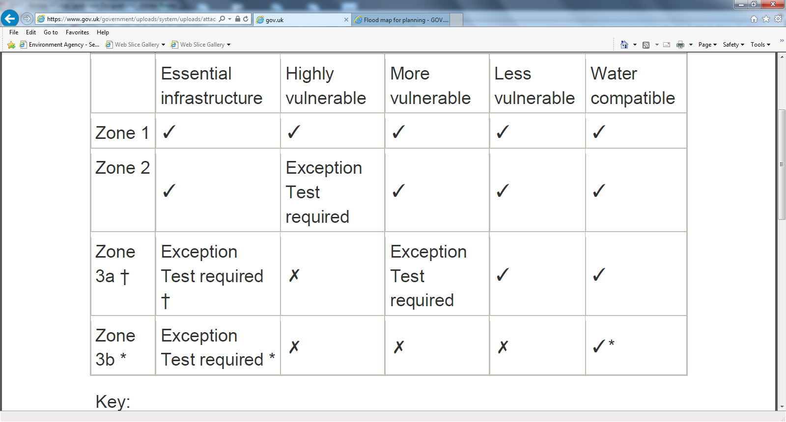
The remainder of PN19 is within Flood zone 1. However, the proposal does not provide any assessment of routes to and from the site to the main transport route (assumed to be Leeds Road). To prevent fluvial flooding this would require a bridge over the river which will present a significant visual impact and destruction of habitat along the river bank.
HBC document “Built and Natural Environment Site Assessments: New Sites 2017” primarily considers the impact of fluvial (river and watercourse) flooding and does not seriously consider the impact from surface water flooding. The surface water flood map for PN 19 is included below (source Gov.uk). This clearly indicates that significant areas are at high and medium risk of surface water flooding. It must also be highlighted that this represents the current flood risk profile and does not take into account the increased impact from permeable surfaces being replaced with large areas of hardstanding. Furthermore, the National Planning Policy Framework (NPPF) sets out how the planning system should help minimise vulnerability and provide resilience to the impacts of climate change. Developers are required to make allowances for the impacts of climate change due to increased rainfall and raising of river levels. Environment Agency document “Flood risk assessments: Climate change allowances” indicates that for the Humber basin an increase in river flow (at Upper percentile) of 20% (for 2015-2039) and 50% (for 2017-2115). This indicates that there will be a significant increase in zone 3 within the development area.
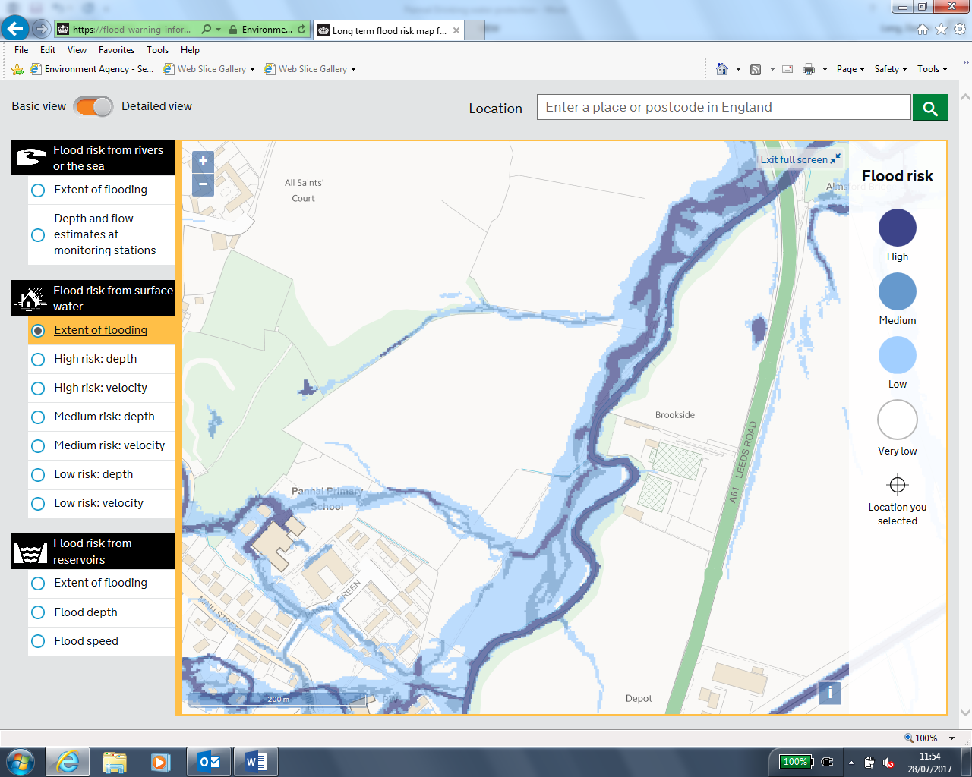

HBC Site Assessment document states that Sustainable urban drainage systems (SuDS) could be used to mitigate the impacts of flooding. This is clearly not appropriate in this case. A SuDS system would not be able to combat the impact of a main river in flood combined with significant surface water run-off.

PN18
The floodplain of the River Crimple runs through the northern most part of PN18. No development should be permitted in the proximity of flood zone 3. The impact of surface water flooding has not been considered for PN18. The surface water flood map can be seen below. Significant areas of PN18 are prone to High and Medium risk of flooding from surface water. This does not take into account of loss of permeable surfaces and climate change.

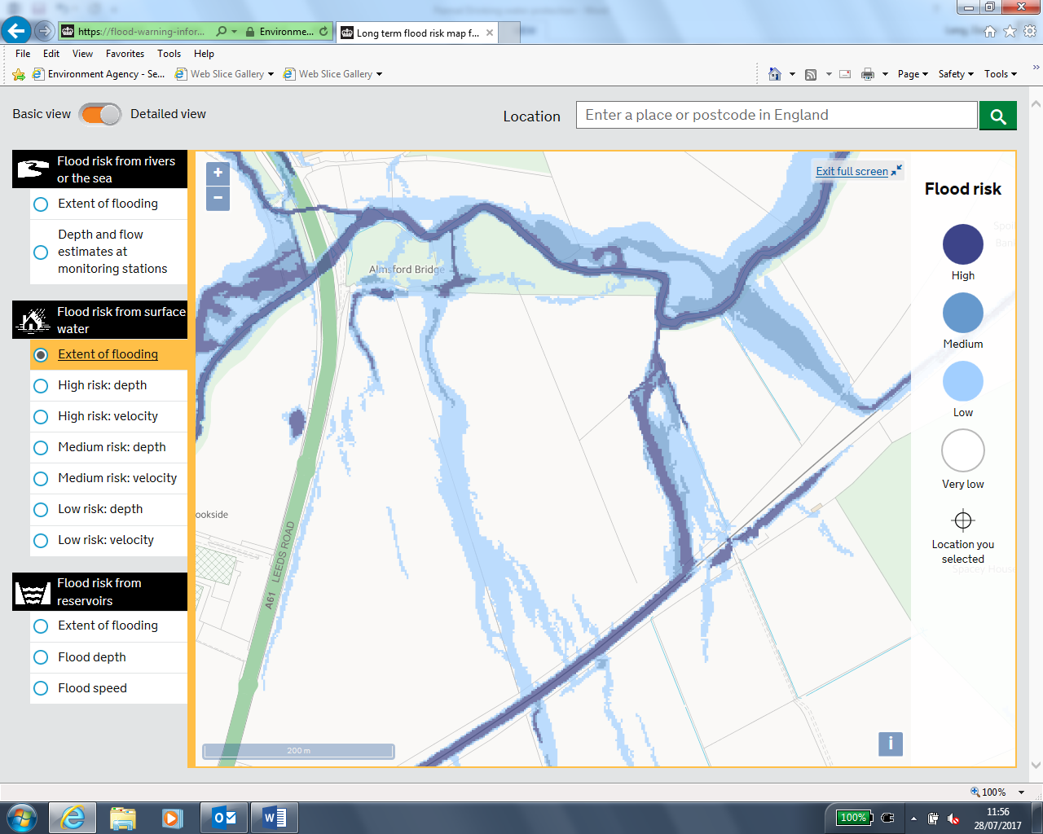

PN17
Local watercourse Clark Beck runs through PN17. The fluvial flood map indicates areas of flood zone 3 within PN17 and as such development should not be permitted in proximity to these areas.
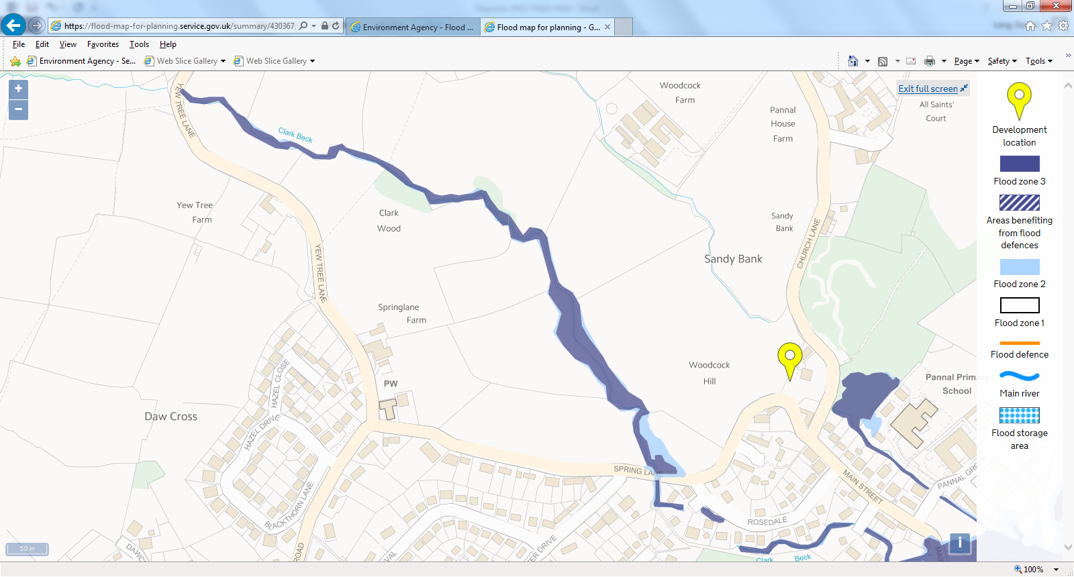

The surface water flood map for PN17 indicates areas at medium risk of surface water flooding – the affected area effectively bisecting the proposed plot.

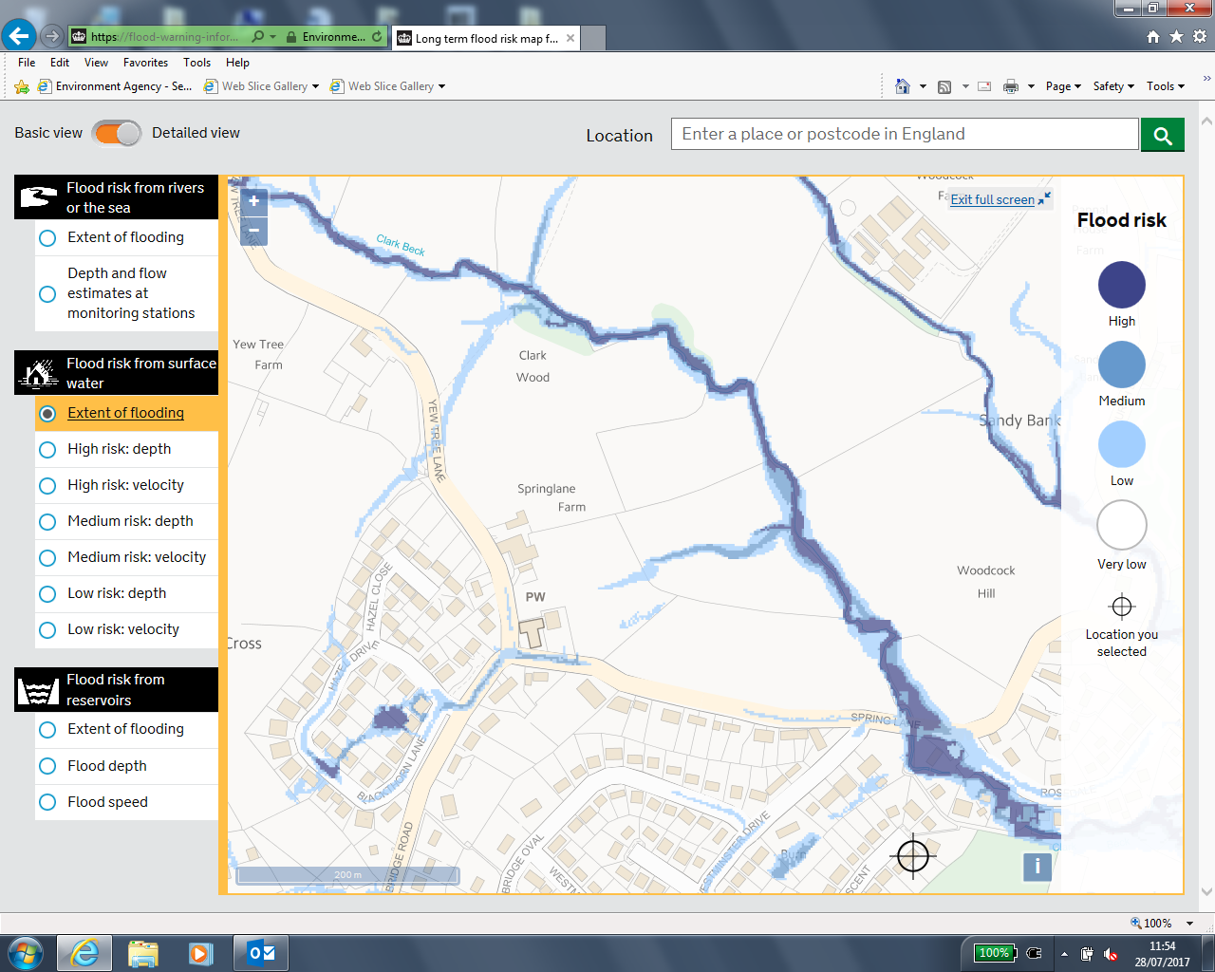

In conclusion – there are significant current and future flooding concerns for all three development areas. The evidence presented would clearly suggest that these areas are not suitable for long term residential/industrial development and should be removed from the local plan.

Biodiversity

HBC have classified Sandy Bank Woods as a Site of Importance for Nature Conservation (SINC). Sandy Bank Woods borders PN19. Policy NE3 within the HBC local plan states development that affects the impact features of Local Sites will only be permitted where an appraisal has demonstrated that significant harm resulting from the development can be avoided through locating on an alternative site with less harmful impacts, adequately mitigated, or as a last resort, compensated for.

HBC Sites Assessment document states in the case of location K37 The development of this site would be likely to have an overall adverse impact on the Farnham Lake South SINC to the north through increased disturbance by people, dogs and cats - unless a substantial buffer of semi-natural habitats together with adequate green infrastructure to provide alternative recreational opportunities were to be provided in association with any development of the site. However such measures would be likely to impact on the overall housing density achievable across the site. It is clear that the same methodology should be applied to Sandy Bank Woods. Development would lead to increased recreational use and should a green buffer be incorporated into the plans the area left for development would be reduced further and therefore inappropriate for use. Both PN17 and PN18 are in close proximity to the SINC and would also lead to an increase in recreational use – particularly the case for PN17.

Sandy Bank Woods are highly likely to support Great Crested Newts. This species is on the European Priority Protection List. In the most recent planning application for extension of Pannal School conditions were requested by NYCC Ecologist to minimise the impact upon this protected species. It is evident that location of a major housing estate adjacent to such a site will have a significant impact particularly during the construction phase. For this reason development should not be allowed in proximity to the SINC.

Trees bordering Clark Beck within PN17 are highly likely to support Bats. Bats, like Great Crested Newts, are on the European Priority Protection list. The impact of construction would have a significant detrimental impact.

Air Quality

HBC undertake ambient air monitoring at a range of location across the district as required by the Environment Act 1995. All HBC monitoring is for Oxides of Nitrogen (NOX) predominantly due to transport. There are currently 2 Air Quality Management Areas (AQMA) with the district 1. Skellgate, Ripon 2. Bond End, Knaresborough. Both of these AQMA’s are for the annual average NOX limit of 40 microg/m3. It is worth noting that HBC are reviewing the requirement for AQMA at York Place, Knaresborough and Woodland Junction, Harrogate.

Despite being one of the major roads serving Harrogate town centre there has been no historical monitoring along Leeds Road. Proposals for PN18 and PN19 do not outline provisions for linking these developments to Leeds Road. Any traffic management scheme would further impede traffic on Leeds Road leading to slower moving vehicles along the full length of the road. Under such circumstances the level of emission would increase from greater idling of vehicles. The current junction between Pannal Main Street/Leeds Road/Follifoot Road would be expected to be impacted further by these plans. This junction would appear very similar to the Woodlands Junction for which an AQMA is being considered. However, there are numerous residential properties (Walton Place/Long Acre Walk) separated only by pavement from Leeds Road. This is not the case at the Woodlands Junction where properties are significantly further from the road. In conclusion, these developments would increase congestion and emissions this increasing the chances of significant impact at sensitive receptors – possibly resulting in an AQMA.

